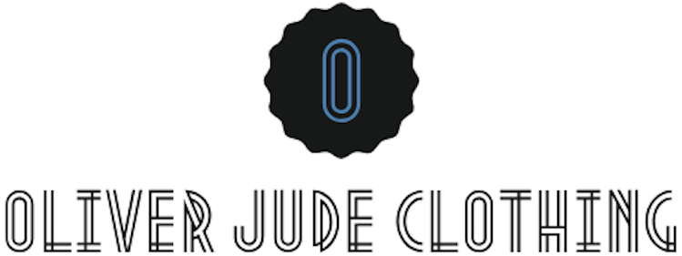

Returns Policy
We appreciate your support whether that is by sharing our message or purchasing from us and we apologise that you aren’t entirely satisfied with your purchase, so we’re here to help.

Returns
You have 30 calendar days to return an item/s from the date you received it. To be eligible for a return, your item/s must be unused and in the same condition that you received it and your item/s will need to have a receipt/proof or purchase.

When asking to return your item/s you will need to take a photograph of your item/s with the receipt/proof of purchase in it and e-mail this to us, using your order number as the subject, then clearly state why you would like to return your item/s in the email. We ask for all of this information so we have it all at once and can deal with your enquiry as quickly as possible.

All of this information you can email to customerservice@oliverjudeclothing.com

Refund
If we decide that your item/s will need to be refunded then once we receive your item, we will inspect it and notify you that we have received your returned item/s. We will immediately notify you on the status of your refund after inspecting the item/s.

If your return is approved and we are satisfied that you are eligible for a refund, we will initiate a refund to your original method of payment, that you provided when placing your order. You will receive your refund within a certain amount of days, depending on your card issuers’ policies.

Shipping
You will be responsible for paying for your own shipping costs for returning your item. Shipping costs will be non-refundable as this cost is out of our control. If you receive a refund, the cost of the return shipping will be deduced from your refund.

Contact Us
If you have any questions on how to return your item/s to us, then please contact us by using the ‘Contact Us’ or ‘Customer Service’ section at www.oliverjudeclothing.com or you can e-mail us at customerservice@oliverjudeclothing.com.

